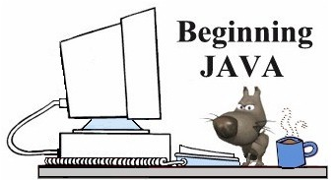
Using BreezyGUI
More Info About the Breezy Boxes
(Working with String input and set precision.)
If you want the user to type String data in the Breezy response box:  . . .  // This program expects user to type his/her name in response  // - - then enter age.  // The information will be displayed in a message box.  public class SampleProgram extends GBFrame  {  Label nameLabel = addLabel ("Name",1,1,1,1);  Label ageLabel = addLabel ("Age",2,1,1,1);  TextField nameField = addTextField ("",1,2,1,1);  IntegerField ageField = addIntegerField (0,2,2,1,1);  Button computeButton = addButton ("Display",3,1,2,1);  public void buttonClicked (Button buttonObj)  {  String name, outputString;  int age;  name = nameField.getText();  age = ageField.getNumber();  outputString= "Name: " + name + "\n" + "Age: " + age + "\n";  messageBox(outputString);  }  public static void main (String[ ] args)  {  Frame frm = new SampleProgram();  frm.setSize (200, 150);  frm.setVisible (true);  }  }  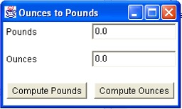 | If you want to display a specific number of decimal places in a Breezy box:  . . .  // This program takes a dollar amount from user  // and converts it to pesos.  // Information will be displayed with two decimal places.  public void buttonClicked (Button buttonObj)  {  double dollar, peso;  peso = PesosField.getNumber();  dollar = peso/10.2;  DollarsField.setNumber(dollar);  DollarsField.setPrecision(2);  }
TextField nameField = addTextField ("",1,2,1,1);
Be careful when entering this line. The correct entry is "" (right tight together) and not " " (with a space in between). If you put in the space, you will need to type a space at the end of the string being entered in the Breezy box for it to be recognized correctly.
If you want to give your Breezy box a title:
Notice that this Breezy box has a title up in the blue area at the top. To create a title, simply add one line of code in main.
public static void main (String[ ] args)
{
Frame frm = new OuncesPounds ();
frm.setSize (250, 150);
frm.setVisible (true);
frm.setTitle("Ounces to Pounds");
}

